Enforcing mandatory fields using UI policies and migrating changes with update sets
Team Leader: HARINI R
Team Members: HARINI A, HARINI R, HARINI R, JANAVI S
Team Id: SWTID-2026-7214
Course: BCA Final Year Project
Date: 13/03/2026

Abstract
This project focuses on improving data accuracy and maintaining proper configuration management within the ServiceNow platform. The main objective is to enforce mandatory fields dynamically using UI Policies and migrate these configuration changes safely between different ServiceNow instances using Update Sets.
In many organizations, users may submit forms with incomplete information, leading to poor data quality and inefficient issue resolution. UI Policies in ServiceNow allow administrators to control form behavior without writing complex scripts. By using UI Policies, certain fields can be made mandatory, visible, or read-only depending on conditions.
Additionally, when changes are made in ServiceNow, they must be migrated from development environments to testing or production environments. Update Sets provide a structured mechanism to capture and transfer configuration changes across instances.
This project demonstrates how UI Policies can enforce mandatory fields dynamically and how Update Sets can be used to migrate these changes effectively. The implementation improves data quality, ensures compliance with organizational standards, and simplifies the deployment process.

Introduction
ServiceNow is a cloud-based platform used by organizations for IT Service Management (ITSM), workflow automation, and digital transformation. One of the key features of ServiceNow is its ability to customize forms and workflows without heavy coding.
In real-world scenarios, forms such as Incident, Problem, or Change Request require certain information to be filled before submission. However, if mandatory rules are not enforced properly, users may submit incomplete records, which affects service management processes.
UI Policies provide a simple way to enforce field requirements dynamically. Administrators can configure rules that automatically change field properties like mandatory, visible, or read-only based on certain conditions.
Another important aspect of ServiceNow development is managing configuration changes. Organizations typically have multiple environments such as Development, Testing, and Production. Update Sets are used to capture configuration changes made in one environment and migrate them to another environment safely.
This project demonstrates the practical implementation of UI Policies and Update Sets in ServiceNow.

Problem Statement
Organizations face the following problems in managing ServiceNow forms:
- Users may submit forms with missing or incomplete information.
- Incomplete records create delays in resolving incidents.
- Manual validation of fields is inefficient.
- Configuration changes made directly in production are risky.
- Lack of proper migration methods may lead to system inconsistencies.
Therefore, it is necessary to implement a system that ensures:
- Required fields are enforced dynamically.
- Users cannot submit forms without entering essential data.
- Configuration changes are properly tracked.
- Changes can be migrated safely between ServiceNow instances.

Objectives
The main objectives of this project are:
- To understand the concept of UI Policies in ServiceNow.
- To enforce mandatory fields dynamically using UI Policies.
- To improve the quality of data entered in ServiceNow forms.
- To track configuration changes using Update Sets.
- To migrate UI Policy configurations from development to another instance.
- To demonstrate the best practices of ServiceNow configuration management.

System Implementation
The implementation of this project is divided into two parts:
- Enforcing Mandatory Fields Using UI Policies
- Migrating Changes Using Update Sets

Implementation Screenshot 1
Screenshot from ServiceNow implementation showing the process step.
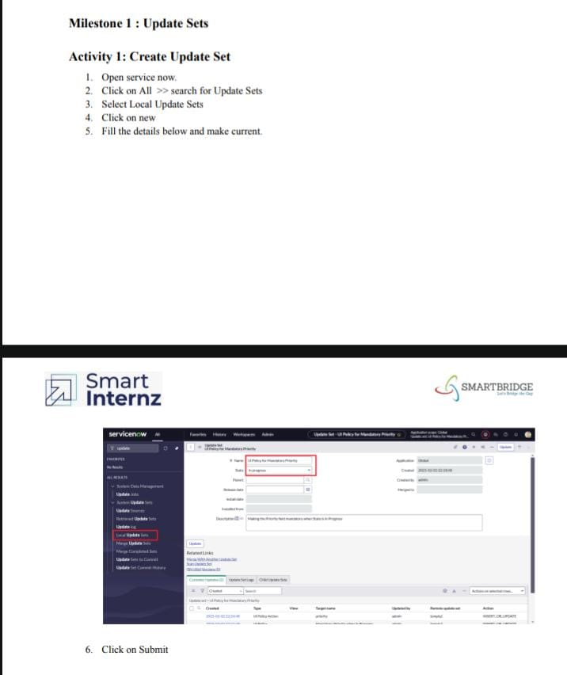

Implementation Screenshot 2
Screenshot from ServiceNow implementation showing the process step.
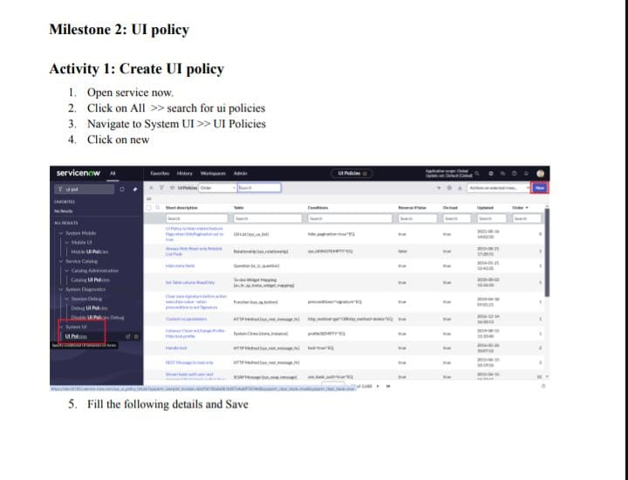

Implementation Screenshot 3
Screenshot from ServiceNow implementation showing the process step.
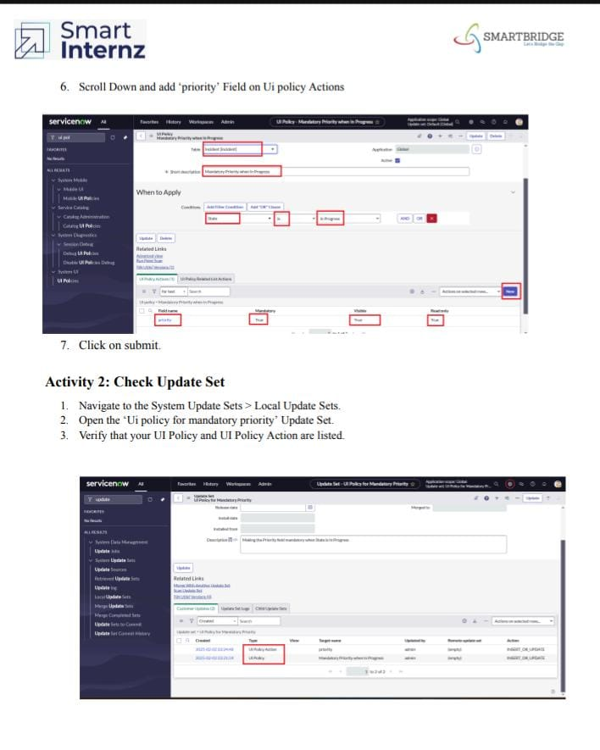

Implementation Screenshot 4
Screenshot from ServiceNow implementation showing the process step.
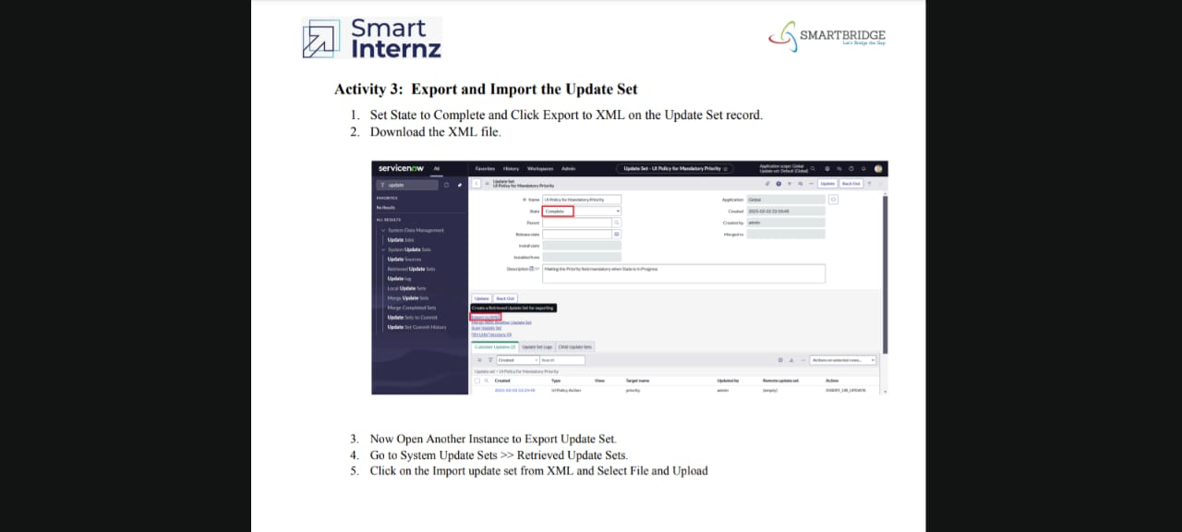

Implementation Screenshot 5

Screenshot from ServiceNow implementation showing the process step.

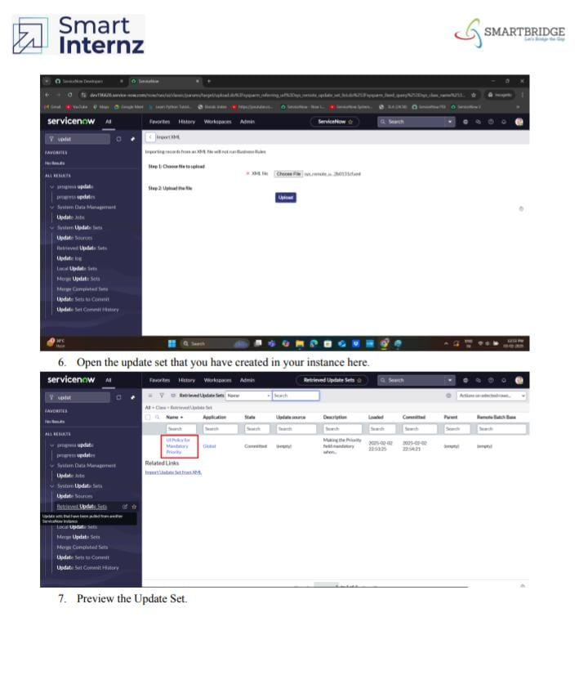

Implementation Screenshot 6

Screenshot from ServiceNow implementation showing the process step.

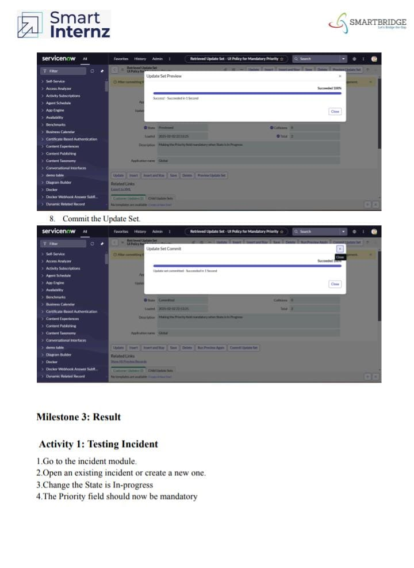

Implementation Screenshot 7

Screenshot from ServiceNow implementation showing the process step.

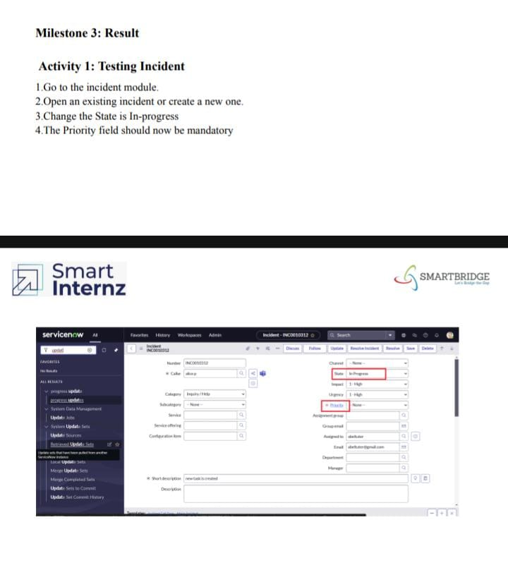

System Implementation
The implementation of this project is divided into two parts:
- Enforcing Mandatory Fields Using UI Policies
- Migrating Changes Using Update Sets

Future Enhancements
Future improvements may include:
- Using Client Scripts for advanced validation
- Automating update set deployment
- Integrating workflows for incident handling
- Implementing role-based UI policies

Conclusion
This project successfully demonstrates how UI Policies can be used to enforce mandatory fields dynamically in ServiceNow forms. The implementation ensures that users provide essential information before submitting records, which improves data quality and operational efficiency.
Additionally, the project explains how Update Sets can be used to migrate configuration changes between ServiceNow instances. This ensures safe deployment of system configurations and helps organizations maintain proper development practices.
Overall, the project highlights the importance of form validation and configuration management in ServiceNow environments.

